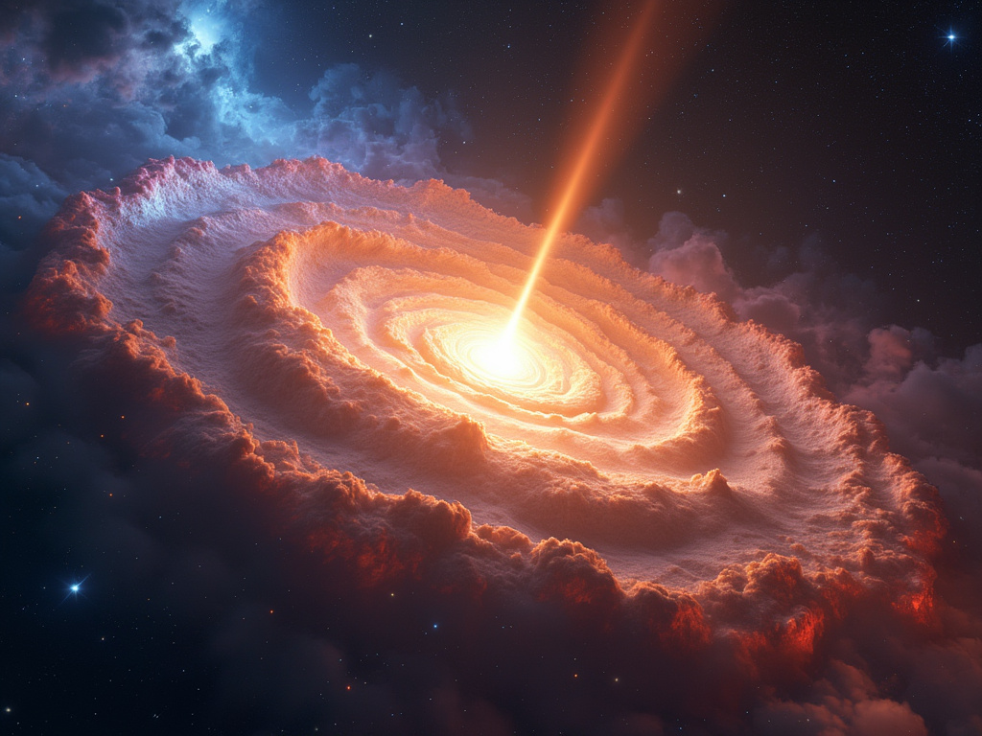

Prompt:

Create a stunning image of a quasar in deep space, radiating intense energy and glowing brightly at its core. The quasar should be surrounded by swirling gas clouds. Streams of light and energy should emanate from the core. The background should be filled with faint stars, emphasizing the quasar's brilliance against the deep space.

GenAI Used: Flux 1.1 Pro (fal.ai)